This Scholarship is in memory of Andrew “Andy” McNamara, a Renville County farm boy who had the desire to be involved in production agriculture. He thoroughly enjoyed the outdoors and was concerned for the environment. Andy is missed by all those who knew his real passions.

There will be awards of (1) $2000.00 Scholarship and (1) $1000.00 Scholarship to be used at the college of the applicants choice.
(Scholarships awarded will be paid directly to the school of choice after the completion of the first semester)

Requirements:
- Member/Participant in BOLD School FFA
- Passion for Agriculture and/or Rural Communities
- Desire to further your education
- Ability to develop leadership skills
- Available to BOLD School Seniors
- Provide a transcript of first semester grades to AVP
- Application Due by April 30th

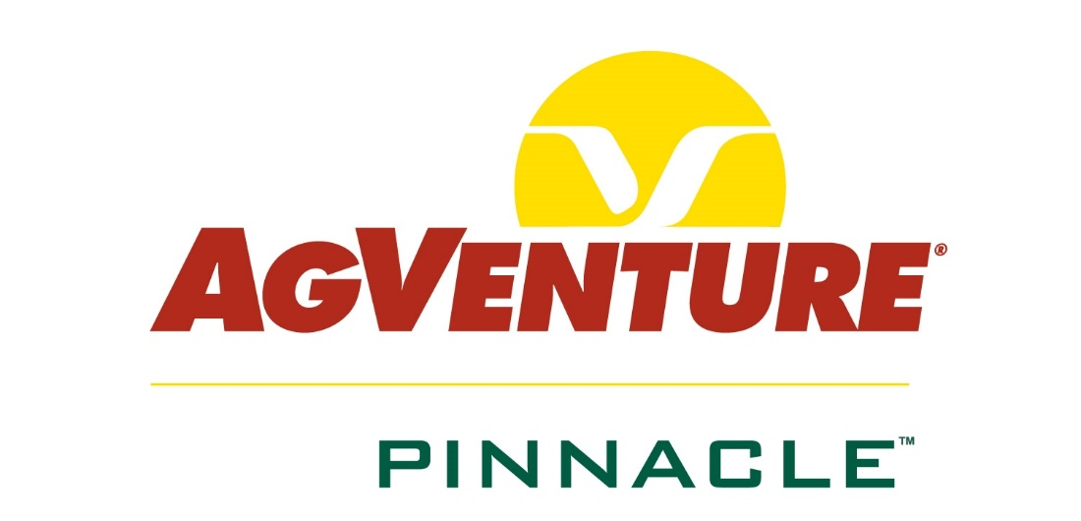
This scholarship is facilitated and selected by AgVenture Pinnacle of Olivia.

Applicant Information
College Information

Name: Click here to enter text. Date of Birth: Click here to enter text.
Address: Click here to enter text. City: Click here to enter text. State/Zip: Click here to enter text.
Phone: Click here to enter text. Cell Phone: Click here to enter text.
Email Address: Click here to enter text.
Parent(s): Click here to enter text.
Address: Click here to enter text. City: Click here to enter text. State/Zip: Click here to enter text.
Phone: Click here to enter text. Cell Phone: Click here to enter text.
Email Address: Click here to enter text.
College Information
College Information

Plan to Attend: Click here to enter text. Start Date: Click here to enter text.
Vocation/Major: Click here to enter text. GPA: Click here to enter text.
What is your career plan/goal? Click here to enter text.
School Activities

Activities: (add additional sheets if necessary) Local/County/State Year(s)
- Click here to enter text. Choose an item. Click here to enter text.
- Click here to enter text. Choose an item. Click here to enter text.
- Click here to enter text. Choose an item. Click here to enter text.
- Click here to enter text. Choose an item. Click here to enter text.
- Click here to enter text. Choose an item. Click here to enter text.
Community Service

Organizations: (add additional sheets if necessary) Local/County/State Year(s)
- Click here to enter text. Choose an item. Click here to enter text.
- Click here to enter text. Choose an item. Click here to enter text.
- Click here to enter text. Choose an item. Click here to enter text.
- Click here to enter text. Choose an item. Click here to enter text.
- Click here to enter text. Choose an item. Click here to enter text.
Statement

What community/school activity or organization has been the most meaningful to your personal and career development?
Click here to enter text.

Work Experience

List experiences including summer employment over the past (4) years.
Job/Title: Employer: Dates: Hrs./Week
- Click here to enter text. Click here to enter text. Click here to enter text. Click here to enter text.
- Click here to enter text. Click here to enter text. Click here to enter text. Click here to enter text.
- Click here to enter text. Click here to enter text. Click here to enter text. Click here to enter text.
- Click here to enter text. Click here to enter text. Click here to enter text. Click here to enter text.
- Click here to enter text. Click here to enter text. Click here to enter text. Click here to enter text.

Essays

Answer (2) of the following questions below.
- Ten years from now a local newspaper does an article on your success story. What does this article say?
Click here to enter text.
- It is our belief everything in rural America is a part of Agriculture directly or indirectly. How do you hope to contribute to agriculture in your future?
Click here to enter text.
- How do you determine success and how did you achieve success to overcome a challenge that you were faced with? How do you evaluate your success?
Click here to enter text.
- What is your passion and how do you plan to use that desire in your future?
Click here to enter text.

*Please submit application to Tammy Park of AgVenture Pinnacle either by mail or email to:
AgVenture Pinnacle
Andrew McNamara Scholarship
PO Box 207
Olivia, MN 56277

tammy.park@avpinnacle.com

Application Due April 30th

