Here at AgVenture Pinnacle of Olivia, we are excited to contribute to the youth in rural areas who are inspired to seek opportunities in agriculture. We feel agriculture surrounds us all in some way either directly or indirectly and we want to help them to become successful in their agricultural goals.

There will be awards of (1) $1000.00 Scholarship and (1) $500.00 Scholarship to be used at the college of the applicants choice.
(Scholarships awarded will be paid directly to the school of choice after the completion of the first semester)
Requirements:
- Member/Participant in FFA and/or 4-H
- Passion for Agriculture and/or Rural Communities
- Desire to further your education
- Ability to develop leadership skills
- Available to High School Seniors in the followings counties In Minnesota: Brown, Chippewa, Kandiyohi, McLeod, Meeker, Redwood, Renville, Sibley, Swift, and the following counties in North Dakota: LaMoure, Dickey
- Provide a transcript of first semester grades to AVP
- Application Due by April 30th
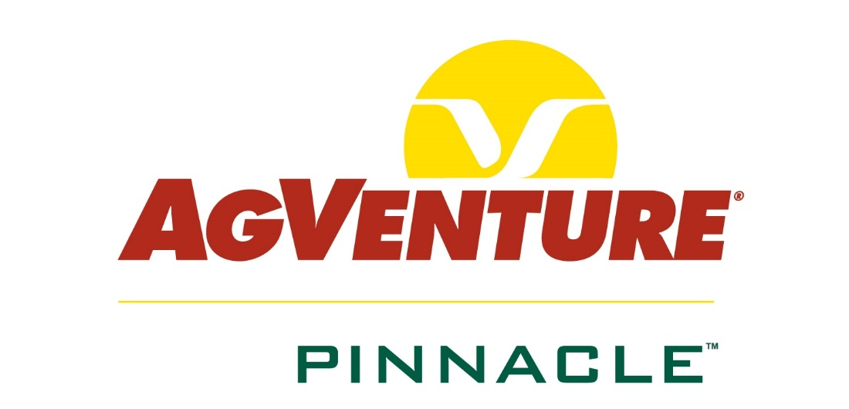

This scholarship is sponsored, facilitated, and selected by AgVenture Pinnacle of Olivia.
Applicant Information
College Information

Name: Click here to enter text. Date of Birth: Click here to enter text.
Address: Click here to enter text. City: Click here to enter text. State/Zip: Click here to enter text.
Phone: Click here to enter text. Cell Phone: Click here to enter text. County: Click here to enter text.
Email Address: Click here to enter text.
Parent(s): Click here to enter text.
Address: Click here to enter text. City: Click here to enter text. State/Zip: Click here to enter text.
Phone: Click here to enter text. Cell Phone: Click here to enter text.
Email Address: Click here to enter text.
College Information
College Information

Plan to Attend: Click here to enter text. Start Date: Click here to enter text.
Vocation/Major: Click here to enter text. GPA: Click here to enter text.
What is your career plan/goal? Click here to enter text.
School Activities

Activities: (add additional sheets if necessary) Local/County/State Year(s)
- Click here to enter text. Choose an item. Click here to enter text.
- Click here to enter text. Choose an item. Click here to enter text.
- Click here to enter text. Choose an item. Click here to enter text.
- Click here to enter text. Choose an item. Click here to enter text.
- Click here to enter text. Choose an item. Click here to enter text.
Community Service

Organizations: (add additional sheets if necessary) Local/County/State Year(s)
- Click here to enter text. Choose an item. Click here to enter text.
- Click here to enter text. Choose an item. Click here to enter text.
- Click here to enter text. Choose an item. Click here to enter text.
- Click here to enter text. Choose an item. Click here to enter text.
- Click here to enter text. Choose an item. Click here to enter text.
Statement

What community/school activity or organization has been the most meaningful to your personal and career development?
Click here to enter text.

Work Experience

List experiences including summer employment over the past (4) years.
Job/Title: Employer: Dates: Hrs./Week
- Click here to enter text. Click here to enter text. Click here to enter text. Click here to enter text.
- Click here to enter text. Click here to enter text. Click here to enter text. Click here to enter text.
- Click here to enter text. Click here to enter text. Click here to enter text. Click here to enter text.
- Click here to enter text. Click here to enter text. Click here to enter text. Click here to enter text.
- Click here to enter text. Click here to enter text. Click here to enter text. Click here to enter text.

Essays

Answer (2) of the following essay questions below or in a separate, typed document.
- Ten years from now a local newspaper does an article on your success story. What does this article say?
Click here to enter text.
- What does Agriculture Mean to Me? My Family?
Click here to enter text.
- Discuss a special attribute or accomplishment that sets you apart from others.
Click here to enter text.
- This scholarship is named “A Great Hand in Farming.” What does “A Great Hand in Farming” mean to you?
Click here to enter text.
- How would an education from (name of college you are applying to) enrich your personal life and help you reach your career goals?
Click here to enter text.
*Please submit application to Tammy Park of AgVenture Pinnacle either by mail or email to:
AgVenture Pinnacle
A Great Hand in Farming Scholarship
PO Box 207
Olivia, MN 56277

tammy.park@avpinnacle.com

Application Due April 30th

